**VISVESVARAYA TECHNOLOGICAL UNIVERSITY**



MINI PROJECT REPORT ON

**“SIMPLE CODE LOCK”**

SUBMITTED BY:

**M.M.Chandrasekharaiah - 1NH18EC709**

Under the guidance of

**Mr.Richard Lincoln Paulraj**

Assistant Professor (2),

Dept. of ECE, NHCE, Bengaluru.

# C:\Documents and Settings\Students\Local Settings\Temporary Internet Files\Content.Word\download (1).jpg

# NEW HORIZON COLLEGE OF ENGINEERING

(ISO-9001:2000 certified, Accredited by NAAC ‘A’, Autonomous college permanently affiliated to VTU)Outer Ring Road, Panathur Post, Near Marathalli, Bengaluru-560103

## NEW HORIZON COLLEGE OF ENGINEERING

## DEPARTMENT OF ELECTRONICS AND COMMUNICATION ENGINEERING



**CERTIFICATE**

Certified that the mini project work entitled “**SIMPLE CODE LOCK**” carried out by**,ChandrasekharaiahMM(1NH18EC709)** bonafide students of Electronics and Communication Department , New Horizon College of Engineering, Bangalore.

The mini project report has been approved as it satisfies the academic requirements in respect of mini project work prescribed for the said degree.

Project Guide HOD ECE

------------------------- -------------------------

**External Viva**

Name of Examiner Signature with Date

1.

2.

**ACKNOWLEDGEMENT**

The satisfaction that accompany the successful completion of any task would be, but impossible without the mention of the people who made it possible, whose constant guidance and encouragement helped us succeed.

We thank **Dr. Mohan Manghnani**, Chairman of **New Horizon Educational Institution**, for providing necessary infrastructure and creating good environment.

We also record here the constant encouragement and facilities extended to us by **Dr.Manjunatha**, Principal, NHCE and **Dr. Sanjeev Sharma**, head of the department of Electronics and Communication Engineering. We extend sincere gratitude to them.

We sincerely acknowledge the encouragement, timely help and guidance to us by our beloved guide **Mr.Richard Lincoln Paulraj** to complete the project within stipulated time successfully.

Finally, a note of thanks to the teaching and non-teaching staff of electronics and communication department for their co-operation extended to us, who helped us directly or indirectly in this successful completion of mini project.

**M.M.Chandrasekharaiah (1NH18EC709)**

**TABLE OF CONTENTS**

ABSTRACT

**CHAPTER 1**

INTRODUCTION…………………………………………………………………………………7

**CHAPTER 2**

LITERATURE SURVEY………………………………………………………………………… 8

**CHAPTER 3**

PROPOSED METHODOLOGY…………………………………………………………………..9

**CHAPTER 4**

PROJECT DESCRIPTION ………………………………………………………………………..10

4.1 HARDWARE DESCRIPTION……………………………………………………………….10

**CHAPTER 5**

RESULTS AND DISCUSSION…………………………………………………………………13

**CHAPTER 6**

CONCLUSION AND FUTURE SCOPE …………………………………………………………15

REFERENCES…………………………………………………………………………………….15

**LIST OF FIGURES**

|  |  |  |
| --- | --- | --- |
| **FIGURE**  **No** | **FIGURE DESCRIPTION** | **Page**  **No** |
| 1 | Pin diagram of 4013 | 10 |
| 2 | Relay | 11 |
| 3 | Transistor | 12 |
| 4 | Circuit diagram | 14 |

### LIST OF TABLES

|  |  |  |  |
| --- | --- | --- | --- |
| **SL**  **No** | **Table**  **No** | **TABLE DESCRIPTION** | **Page**  **No** |
| 1 | 1 | Components | 9 |
| 2 | 2 | Problems | 14 |

**ABSTRACT**

Today people are facing more problems about security in all over world, nowadays security is the most essential issue everywhere in the world. So security of everything gains higher and higher importance in recent years. Here in this project, trying to reproduce the comprehensive literature study related to the code locks and gate security systems that are necessary in the fields such as home, industries and vehicle security where possibilities of incursion are increasing day by day. In past days, the research is gone on various door lock security systems like traditional security systems which provide indications using alarm.

In this project we use simple mechanism of flip flops which provide the facility of a small storage. This circuit consists of two flop flops that are given the input of 4 digit code .Each IC consists of two flip flops. The four inputs of flip flops are named as A,B,C and D. For example if the code to be setup is 1234,1 is given to A,2 to B,3 to C,4 toD. The rest other digits are given to reset of the flip flops. When a switch is pressed, It makes the input clock pin high and the state of flip flop is changed. The output of 1 flip flop is given to the input of other flip flop and the input of first flip flop is grounded. Thus when right sequence of keys are pressed the relay energises through the transistor.

**INTRODUCTION**

Our Project is basically an electronic combination lock for daily use. This code lock responds only to the right sequence of four digits that can be punched in through the nine keys available on a typical keypad. If an incorrect key is pressed, the lock gets automatically reset. This uses the mechanism of flip flops and not forgetting the relay which acts as a switch. This relay is energized when current passes through it.

**LITERATURE SURVEY**

Lock security systems are classified based on technology used as

1) Password based (The programmable electronic code lock and it is called as integrated combinational type lock)

2) Biometric based (The palmtop recognition is the next step for fingerprint recognition.)

3) GSM based (In many door lock security system GSM is used for communication purpose.)

4) Smart card based (The security entry way where valid smart card RFID is necessary for passing the door.)

5) RFID based (It is the security system used for digital door lock)

6) Bluetooth based (Bluetooth based system is a bit like survey house innovations that utilizes Bluetooth function available in smart devices)

7) Social networking sites based (The digitalization and safety perspectives were accomplished by utilizing the phone device and web camera.)

8) OTP based (The proposed method in latest work does not need administrator’s help to access the facility if the user knows OTP technique and has a registered mobile phone)

9) Motion detector based (The Motion Detector System working is based on the principle of amount of light falling on the photodiode.)

10) VB based (Electronic eye represents the model for capturing the door images with the help of microcontroller to ensure the safety for offices and houses.)

11) Combined system (The locker security system is as RFID, FINGERPRINT, PASSWORD and GSM technology containing door locking frameworks)

**PROPOSED METHODOLOGY**

* Collecting components
* Understand the function of each component
* Construction of the circuit
* Observation of result and verification

**PROJECT DESCRIPTION**

The circuit is built around two IC-4017. The clock pins of the four flip-flops are connected to A, B, C, and D pads. The correct code sequence for activation of relay RL1 is sensitized by clocking points A, B, C, and D in that order. The five remaining switches are connected to reset pad which resets all the flip-flops.

Touching the key pad switch A/B/C/D briefly pulls the clock input pin high and the state of flip-flop is altered. The Q output pin of each flip-flop is wired to D input pin of the next flip-flop while D pin of the first flip-flop is grounded.

A code lock can be used for numerous applications in which access to a gadget is to be restricted to a limited number of persons. The connected appliance is turned on only when correct four digits code is entered. Any wrong key pressed will be re set the lock. The circuit can be used in number of ways depending upon a person’s desire or requirement in various applications for example as access control system, TV child lock, car security system or as an electronic door lock system.

|  |  |  |  |
| --- | --- | --- | --- |
| S.No. | Required Components | Remarks | Quantity |
| 1 | IC’s | 4017 | 1 |
| 2 | Transistor | BC557 PNP transistor | 1 |
| 3 | Diode | 1NH4001 | 1 |
| 4 | LED | Colored | 1 |
| 5 | Resistor | Quarter watt | 100k ohm - 2  5k Ohm – 1  1k Ohm - 1 |
| 6 | Capacitor | Ceramic and dielectric | 0.1mf,ceramic – 2  220mf ,25v |
| 7 | Switches | Push to on | 9 |
| 8 | Relay | 12v 150 Ohm | 1 |

Table 1: components

IC4017 pin Diagram :

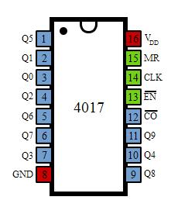

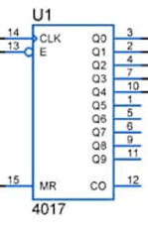 Fig 1: (IC4017 pin Diagram)

### An Introduction to IC4017

Most of us are more comfortable with 1, 2, 3, 4… rather than 001, 010, 011, 100. We mean to say that we will need a decimal coded output in many cases rather than a raw binary output. We have many counter ICs available but most of them produce binary data as an output. We will again need to process that output by using decoders or any other circuitry to make it usable for our application in most of the cases.

Let us now introduce you a new IC named IC 4017. It is a CMOS decade counter cum decoder circuit which can work out of the box for most of our low range counting applications. It can count from zero to ten and its outputs are decoded. This saves a lot of board space and time required to build our circuits when our application demands using a counter followed by a decoder IC. This IC also simplifies the design and makes debugging easy.

it has 16 pins and the functionality of each pin is explained as follows:

* Pin-1: It is the output 5. It goes high when the counter reads 5 counts.
* Pin-2: It is the output 1. It goes high when the counter reads 0 counts.
* Pin-3: It is the output 0. It goes high when the counter reads 0 counts.
* Pin-4: It is the output 2. It goes high when the counter reads 2 counts.
* Pin-5: It is the output 6. It goes high when the counter reads 6 counts.
* Pin-6: It is the output 7. It goes high when the counter reads 7 counts.
* Pin-7: It is the output 3. It goes high when the counter reads 3 counts.
* Pin-8: It is the Ground pin which should be connected to a LOW voltage (0V).
* Pin-9: It is the output 8. It goes high when the counter reads 8 counts.
* Pin-10: It is the output 4. It goes high when the counter reads 4 counts.
* Pin-11: It is the output 9. It goes high when the counter reads 9 counts.
* Pin-12: This is divided by 10 output which is used to cascade the IC with another counter so as to enable counting greater than the range supported by a single IC 4017. By cascading with another 4017 IC, we can count up to 20 numbers. We can increase and increase the range of counting by cascading it with more and more IC 4017s. Each additional cascaded IC will increase the counting range by 10. However, it is not advisable to cascade more than 3 ICs as it may reduce the reliability of the count due to the occurrence glitches. If you need a counting range more than twenty or thirty, I advise you to go with conventional procedure of using a binary counter followed by a corresponding decoder.
* Pin-13: This pin is the disable pin. In normal mode of operation, this is connected to ground or logic LOW voltage. If this pin is connected to logic HIGH voltage, then the circuit will stop receiving pulses and so it will not advance the count irrespective of number of pulses received from the clock.
* Pin-14: This pin is the clock input. This is the pin from where we need to give the input clock pulses to the IC in order to advance the count. The count advances on the rising edge of the clock.
* Pin-15: This is the reset pin which should be kept LOW for normal operation. If you need to reset the IC, then you can connect this pin to HIGH voltage.
* Pin-16: This is the power supply (Vcc) pin. This should be given a HIGH voltage of 3V to 15V for the IC to function.

**Relay:**

A relay is classified into many types, a standard and generally used relay is made up of electromagnets which in general used as a switch. The signal received from one side of the device controls the switching operation on the other side. So relay is a switch which controls (open and close) circuits electromechanically. The main operation of this device is to make or break contact with the help of a signal without any human involvement in order to switch it ON or OFF. It is mainly used to control a high powered circuit using a low power signal.

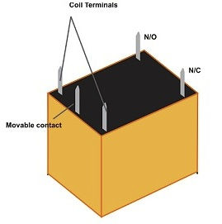

Fig 2: Relay

Diode:

**Diode**, An electrical component that allows the flow of current in only one direction. In circuit diagrams, a diode is represented by a triangle with a line across one vertex. The most common type of diode uses a p n junction. In this type of diode, one material (*n*) in which electrons are charge carriers abuts a second material (*p*) in which holes (places depleted of electrons that act as positively charged particles) act as charge carriers. At their interface, a depletion region is formed across which electrons diffuse to fill holes in the *p*-side. This stops the further flow of electrons. When this junction is forward [biased](https://www.merriam-webster.com/dictionary/biased) (that is, a positive voltage is applied to the *p*-side), electrons can easily move across the junction to fill the holes, and a current flows through the diode. When the junction is reverse biased (that is, a negative voltage is applied to the *p*-side), the depletion region widens and electrons cannot easily move across. The current remains very small until a certain voltage (the breakdown voltage) is reached and the current suddenly increases.

Transistor :

There are typically three electrical leads in a transistor, called the emitter, the collector, and the base. An electrical signal applied to the base (or gate) influences the semiconductor material’s ability to conduct electrical current, which flows between the emitter and collector in most applications. A voltage source such as a battery drives the current, while the rate of current flow through the transistor at any given moment.

* Driver Modules like Relay Driver, LED driver
* Amplifier modules like Audio amplifiers, signal Amplifier

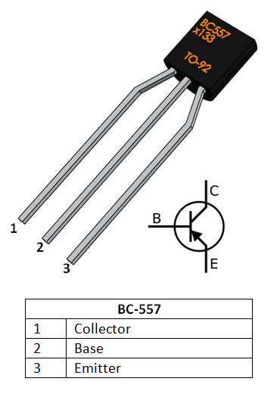

Fig 3:Transistor

**Resistor**

A passive electrical component with two terminals that are used for either limiting or regulating the flow of electric current in electrical circuits.

## Color Coding of Resistors

Resistors may not display the value outside but resistor color pattern through their resistance can be calculated. PTH (plated-through-hole) resistors use a color- coding system (which really adds some flair to circuits), and SMD (surface-mount-device) resistors have their own value-marking system.

Following is a table with color code of resistors

|  |  |
| --- | --- |
| **Color** | **Color code** |
| Black | 0 |
| Brown | 1 |
| Red | 2 |
| Orange | 3 |
| Yellow | 4 |
| Green | 5 |
| Blue | 6 |
| Violet | 7 |
| Grey | 8 |
| White | 9 |

|  |  |
| --- | --- |
| **Colour** | **Tolerance** |
| Brown | ±1% |
| Red | ±2% |
| Gold | ±5% |
| Silver | ±10% |

## Resistors in Parallel

Resistors are said to be in parallel when the terminals of resistors are connected to the same two nodes. Resistors in parallel share the same voltage at their terminals.

### Resistors in Parallel Formula

|  |
| --- |
| 1Rtotal=1R1+1R2+…..+1Rn |

Where,

* 1Rtotal is the sum of all the individual resistances

## Applications of Resistor

* Wire wound resistors find application where balanced current control, high sensitivity, and accurate measurement are required like in shunt with ampere meter.
* Photo resistors find application in flame detectors, burglar alarm, in photographic devices, etc.
* Resistors are used for controlling temperature and voltmeter.
* Resistors are used in digital multi-meter, amplifiers, telecommunication, and oscillators.
* They are also used in modulators, demodulators, and transmitters.

## 

**Led**

A **light-emitting diode** (**LED**) is a semi conductor light source that emits light when [current](https://en.m.wikipedia.org/wiki/Electric_current) flows through it. [Electrons](https://en.m.wikipedia.org/wiki/Electron) in the semiconductor recombine with [electron holes](https://en.m.wikipedia.org/wiki/Electron_hole), releasing energy in the form of [photons](https://en.m.wikipedia.org/wiki/Photon). The color of the light (corresponding to the energy of the photons) is determined by the energy required for electrons to cross the [band gap](https://en.m.wikipedia.org/wiki/Band_gap) of the semiconductor.

Benefits of LEDs and IREDs, compared with incandescent and fluorescent illuminating devices, include:

* **Low power requirement**: Most types can be operated with battery power supplies.
* **High efficiency:** Most of the power supplied to an LED or IRED is converted into radiation in the desired form, with minimal heat production.
* **Long life:** When properly installed, an LED or IRED can function for decades.

Typical applications include:

* **Indicator lights:** These can be two-state (i.e., on/off), bar-graph, or alphabetic-numeric readouts.
* **LCD panel backlighting:** Specialized white LEDs are used in flat-panel computer displays.
* **Fiber optic data transmission:** Ease of [modulation](https://searchnetworking.techtarget.com/definition/modulation) allows wide communications [bandwidth](https://searchnetworking.techtarget.com/definition/bandwidth) with minimal noise, resulting in high speed and accuracy.
* **Remote control:** Most home-entertainment "remotes" use IREDs to transmit data to the main unit.
* [**Optoisolator**](https://searchnetworking.techtarget.com/definition/optoisolator)**:** Stages in an electronic system can be connected together without unwanted interaction.

https://ssl.gstatic.com/ui/v1/icons/mail/images/cleardot.gif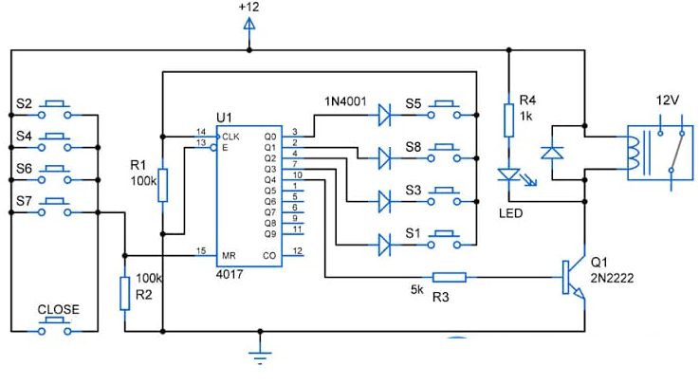

Fig4: Circuit diagram of circuit

|  |  |  |
| --- | --- | --- |
| Sr.No. | **Problems** | |
| 1 | Specific Techniques | Can’t change the password, during power failure system will gets off. |
| 2 | One Time Password | Timeout in few seconds and multiple uses means multiple lockouts. |

Table 2: Problems

**Push Button Switch**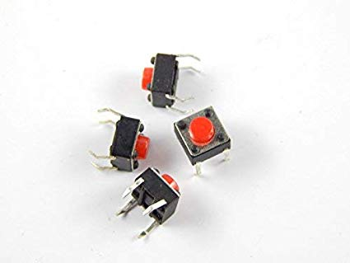

**Where to use push button?**

Push-Buttons are normally-open **tactile switches**. Push buttons allow us to power the circuit or make any particular connection only when we press the button. Simply, it makes the circuit connected when pressed and breaks when released. A push button is also used for triggering of the SCR by gate terminal. These are the most common buttons which we see in our daily life electronic equipment’s.

**Applications**

* Calculators
* Push-button telephones
* Kitchen appliances
* Magnetic locks
* Various other mechanical and electronic devices, home and commercials.

**CONCLUSION AND FUTURE SCOPE**

In today’s technologically advanced world, autonomous systems are gaining rapid popularity so the advancement in latest technology is continuously and rapidly made on different latest automatic door lock security systems. The need for an advanced door lock security systems using new technologies is increases day by day as security become a very important or serious issue for everybody. Due to the recent trends in various methods of security for home, buildings, companies vehicles etc. There is no need to worry about this security any longer, as automatic security systems are here to deal with it. This paper tries to focus all recent door lock security systems in a comprehensive way.

And as per our knowledge, not a single system is suitable for all types of applications. Day by day technologies are developing and techniques of robbery are also developing. So, need is to develop a new smart and unbreakable technique in further studies.

**REFERENCES**

Electronics For You

magazines 2017 -18